**CYBERSECURITY CAPSTONE PROJECT**

**Cyber Hygiene and Best Practices**

**Making Our Very Own Password Checker**

Short Weak Password

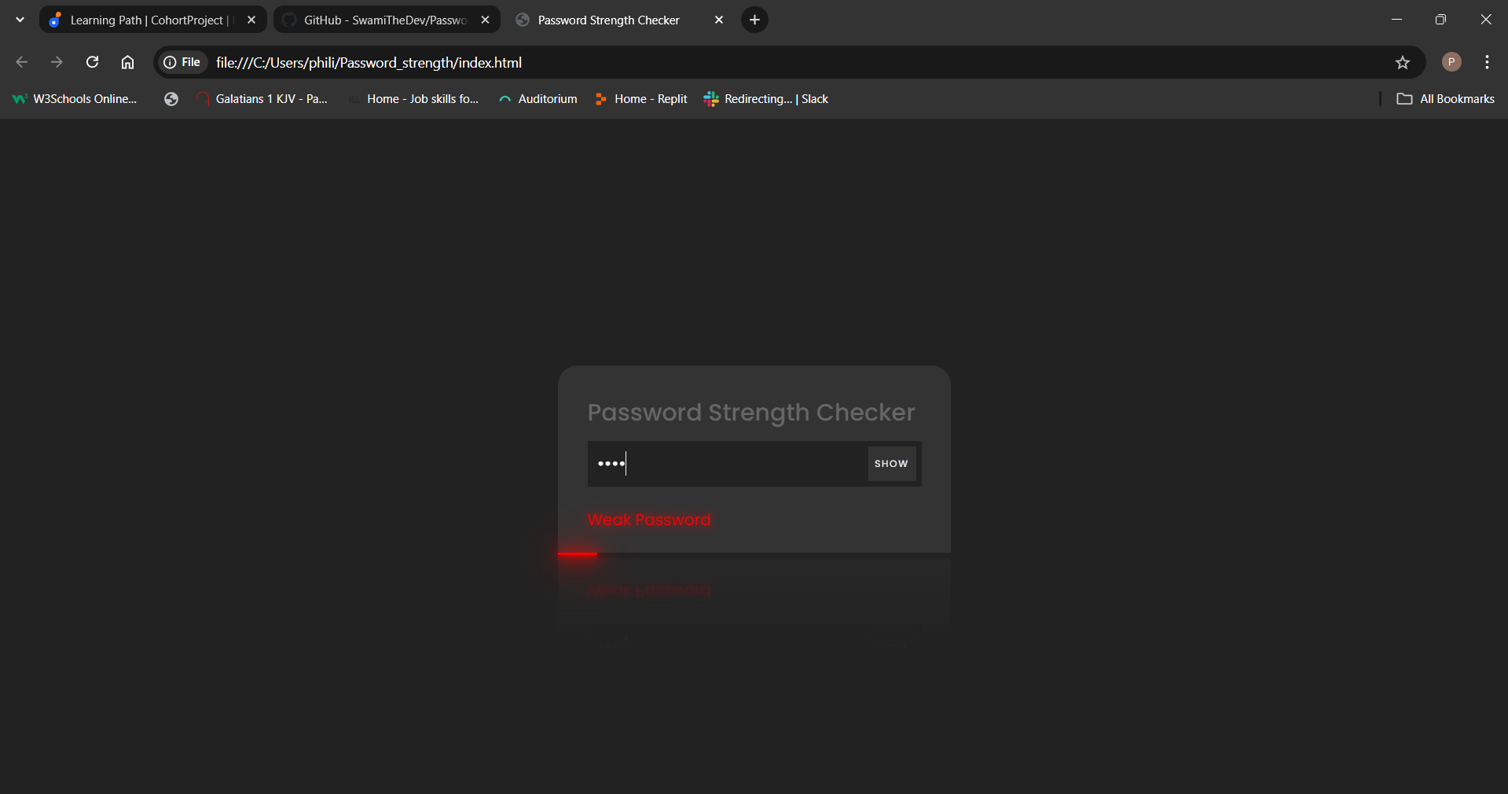

Long Weak Password

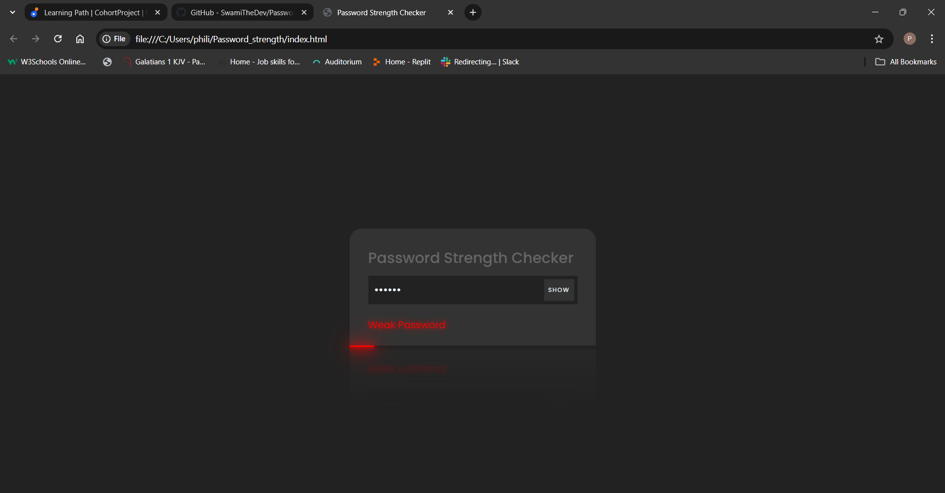

Very Short but Moderate Password

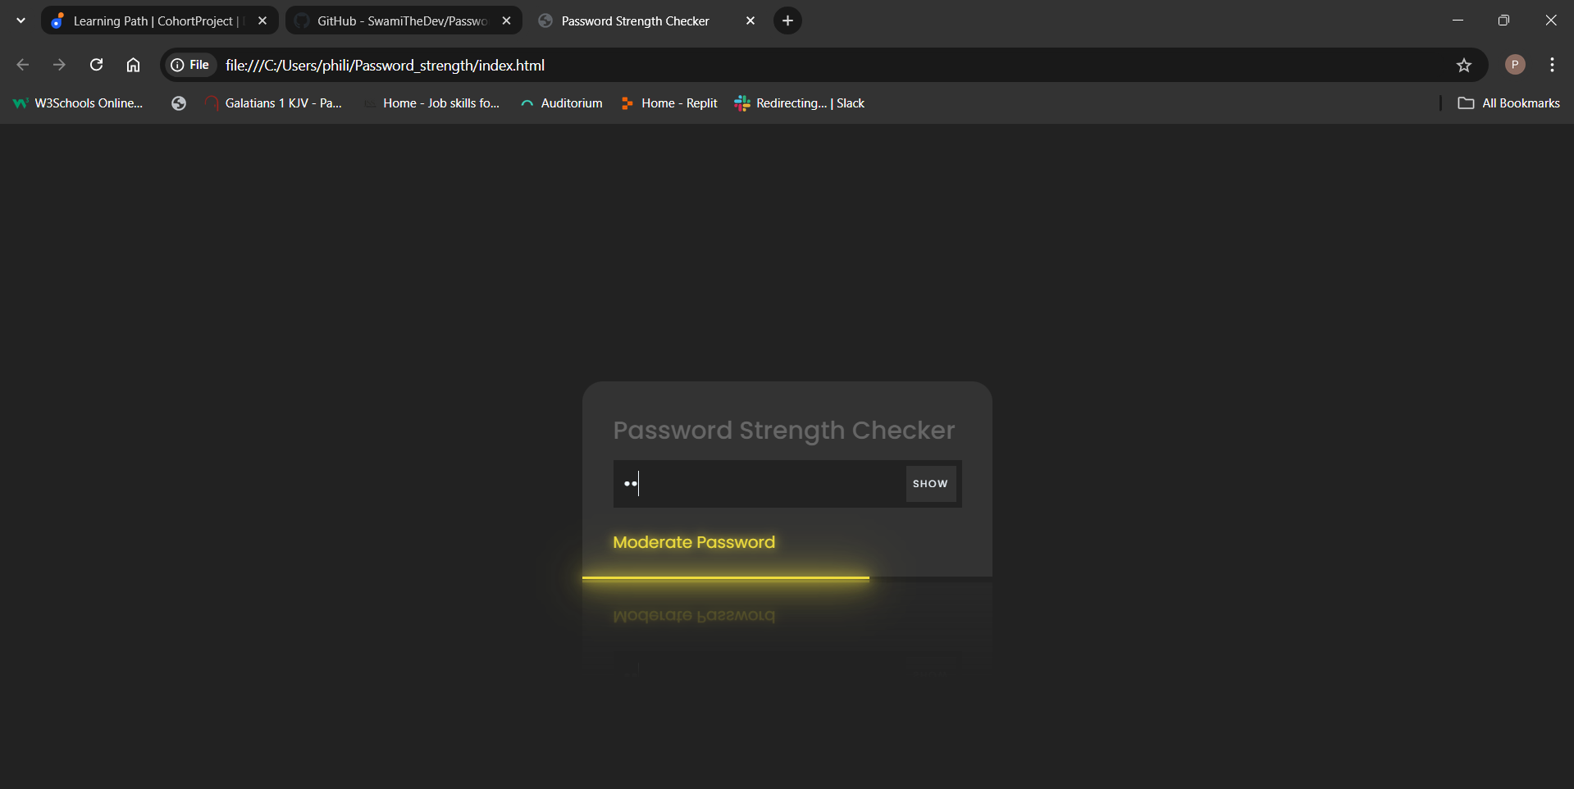

Long Moderate Password

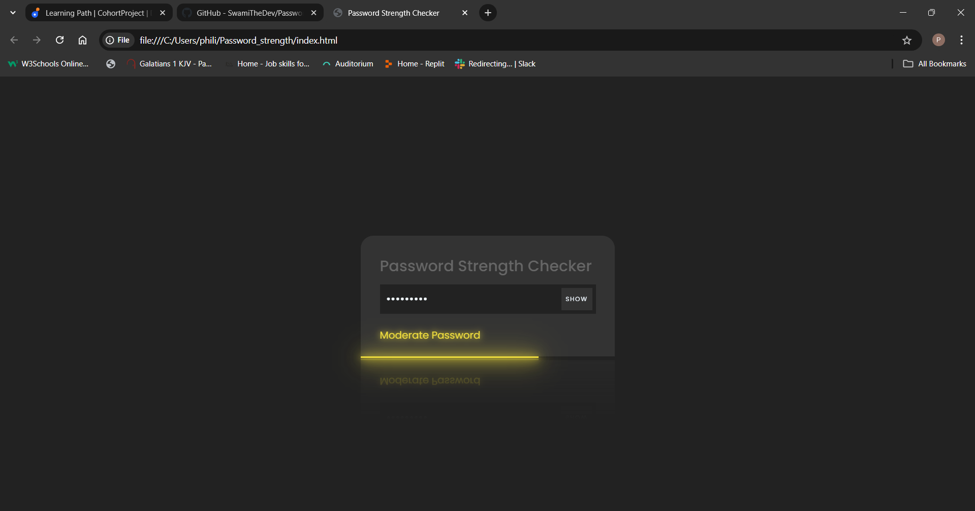

Super Long but Moderate Password

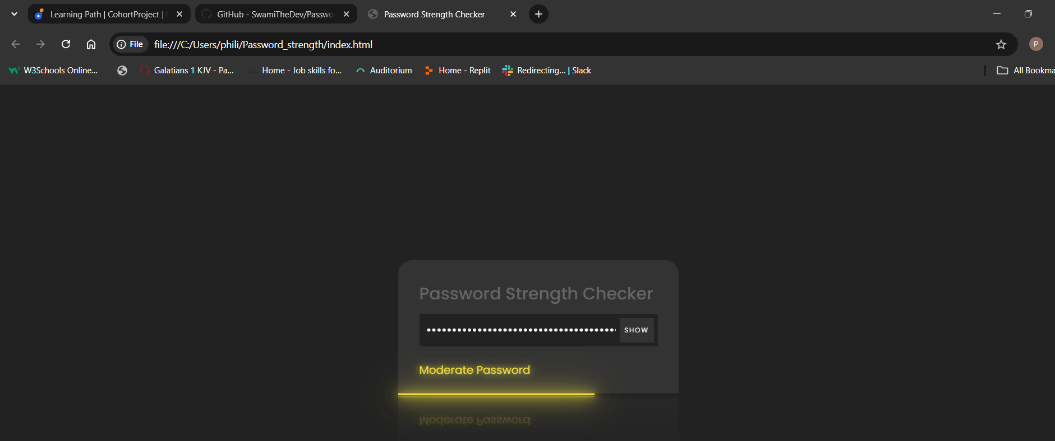

Strong Password

